 |  |  |  |  |  | 
 |  | 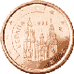 |  |  | 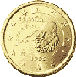
 |  |  |  |  |  | 
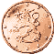 |  |  | 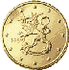 |  |  |  | 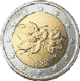
 |  |  |  |  | 
F | F - D - J - A | 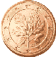D
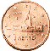F | 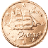F | 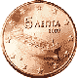F |  |  |  |  | 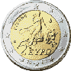S

